**GOVERNMENT COLLEGE OF ENGINEERING [IRTT]**

**ERODE: 638 316**



**Electronics and Communication Engineering**

**NAAN MUDHALVAN**

**DIGITAL MARKETING**

**ASSIGNMENT**

NM ID: 0D702C140568A61AA604FF64443F813B

NAME: NANDHINI J

*BRAND NAME: NATURE’S NEST*

*CATEGORY: ORGANIC PRODUCTS*

1. Create a blog or website using Blogspot and WordPress. Customize the theme design and post new article with 500 words

Link: Blog using Blogspot

<https://naturesnesst.blogspot.com/>

Screenshot:

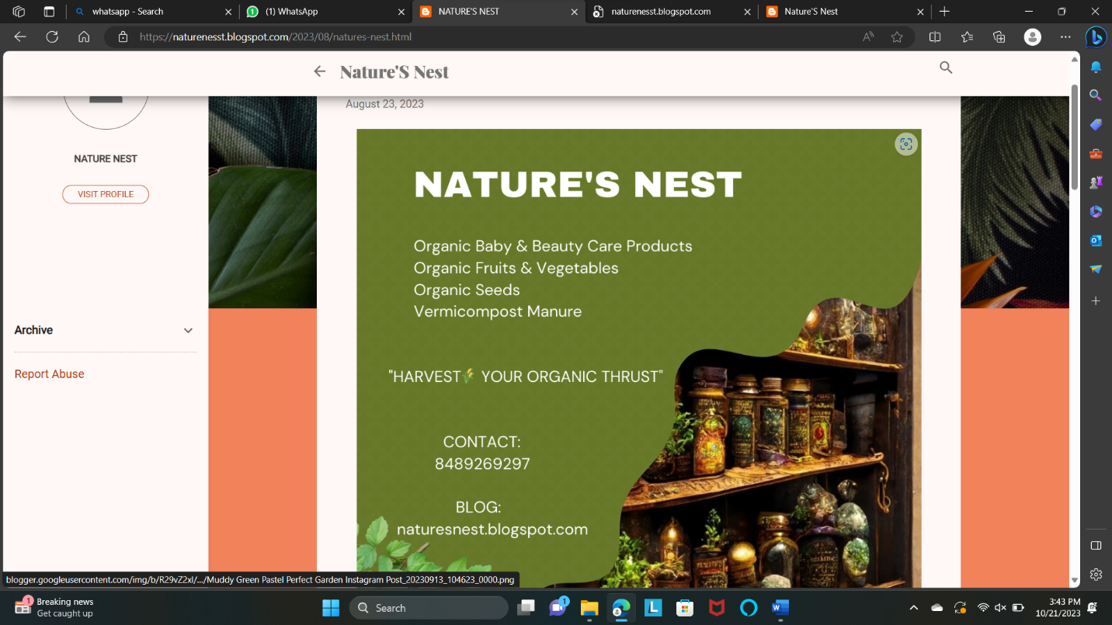

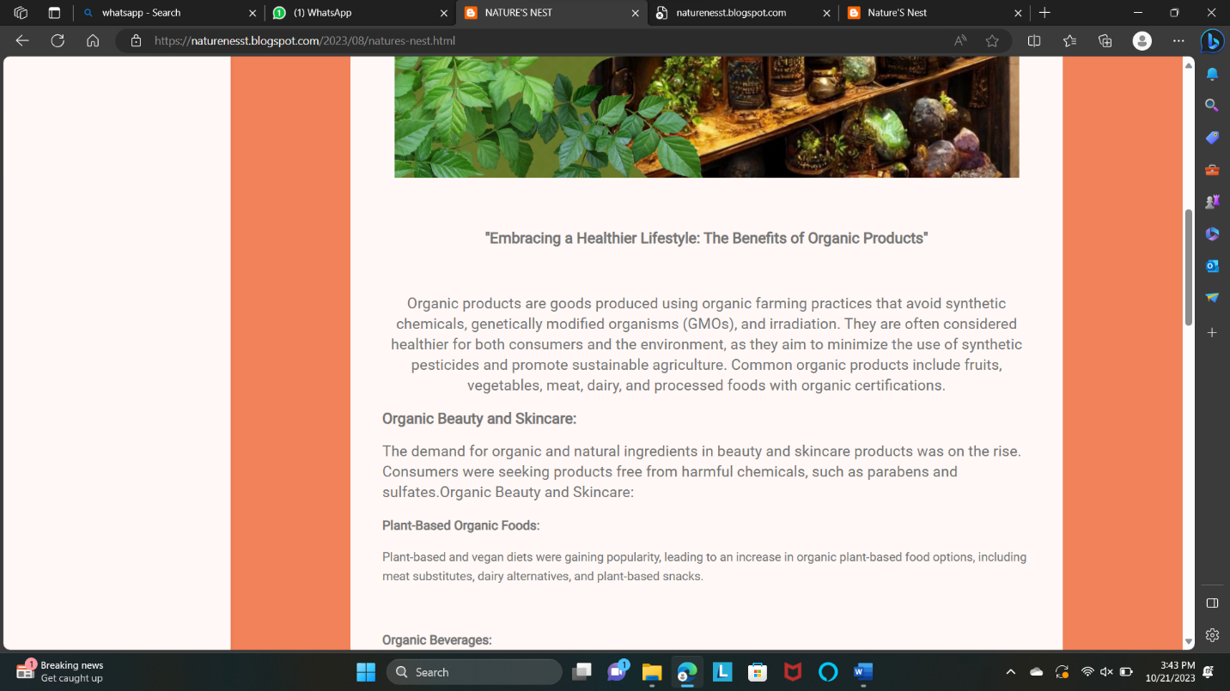

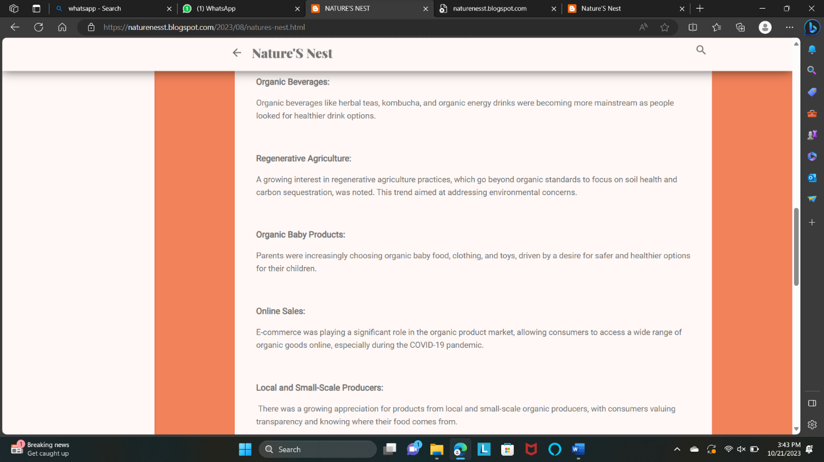

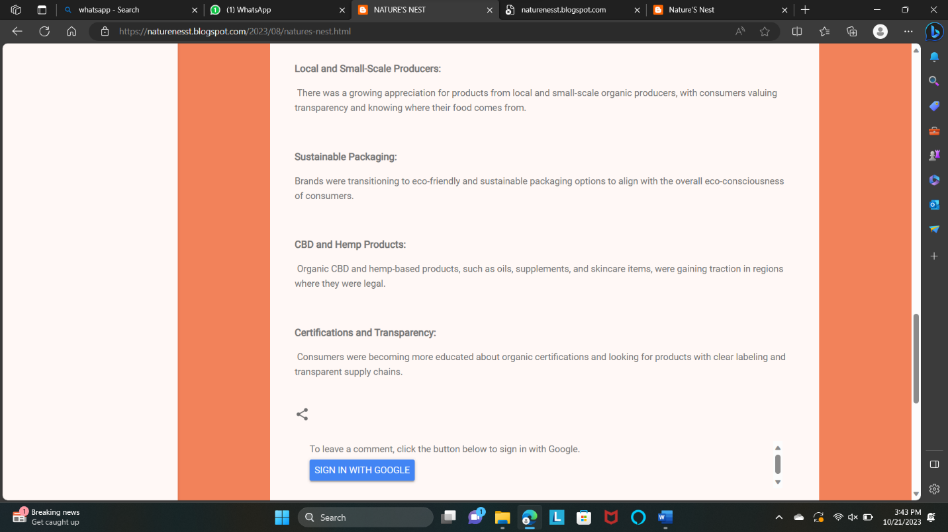

2.Create a New Facebook Business Page and post one social media poster for your brand.

Link: Facebook business page

<https://www.facebook.com/profile.php?id=61550884361022&mibextid=ZbWKwL>

Screen shot:

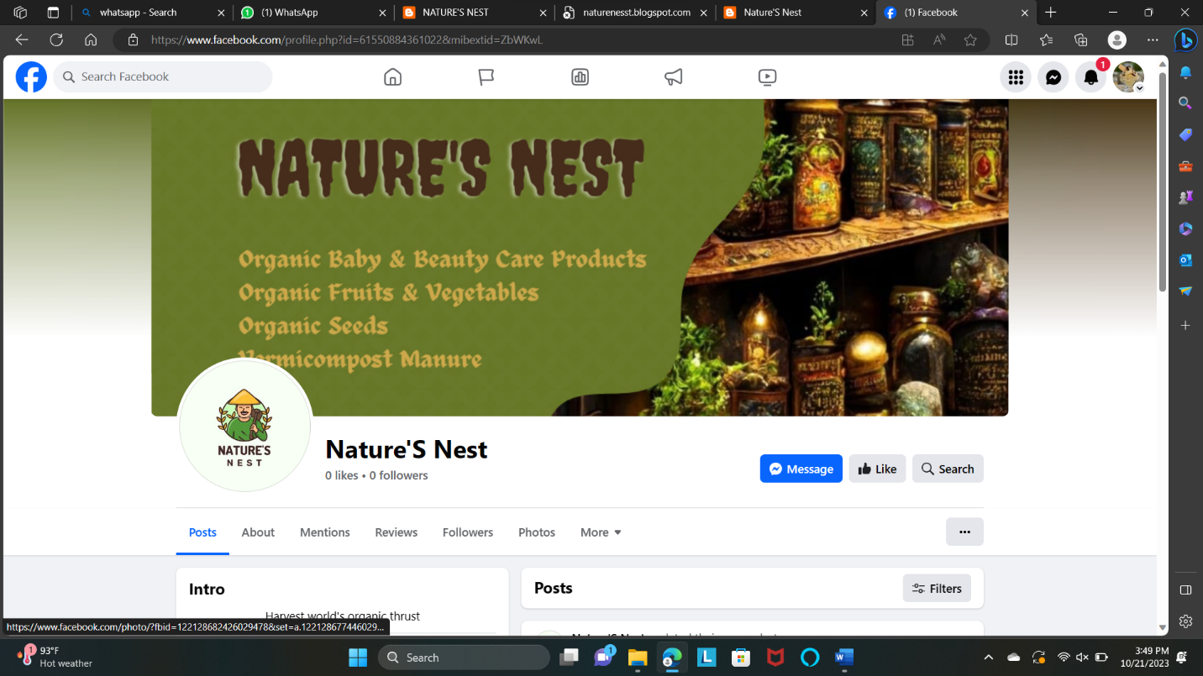

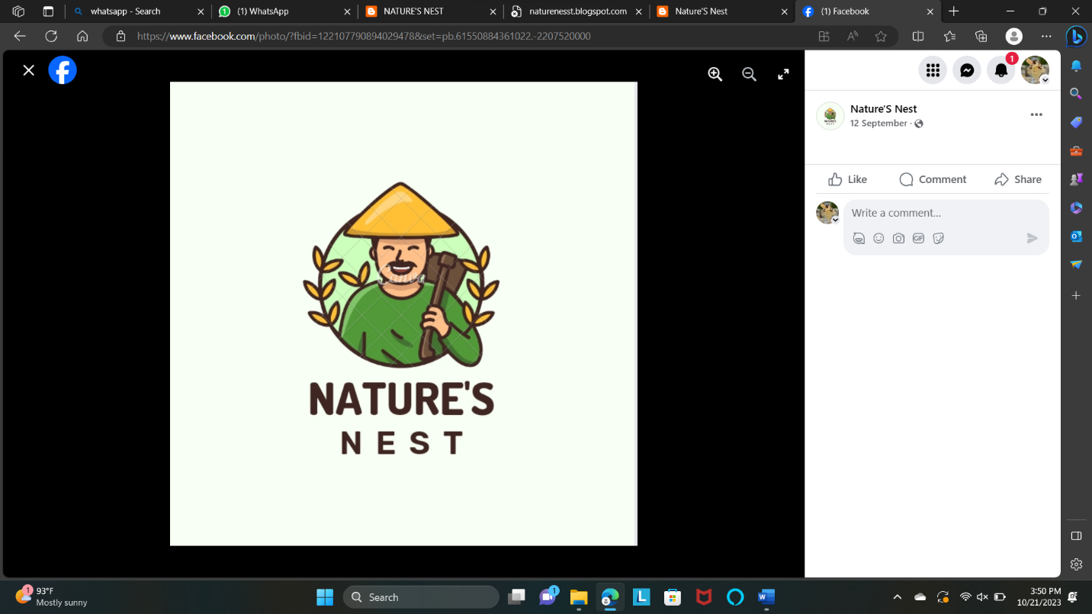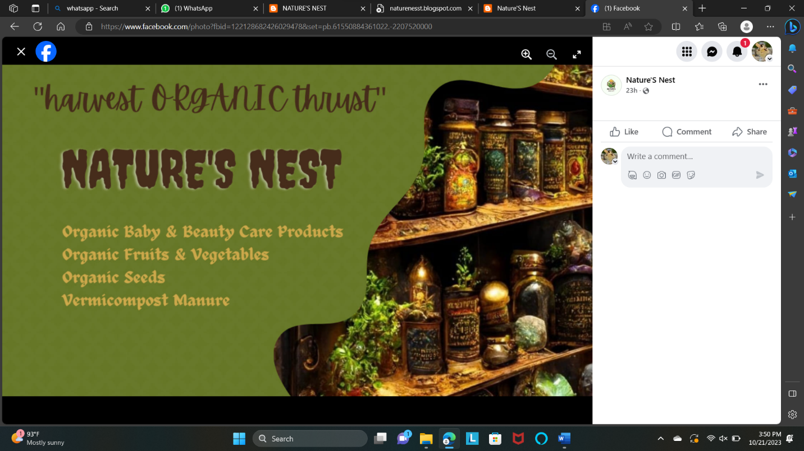

3.Create and design a social media advertisement poster using canva.

Link: Infographics Page Design using Canva

<https://www.blogger.com/u/2/blog/post/edit/7958495218103469647/8858615079332102655>

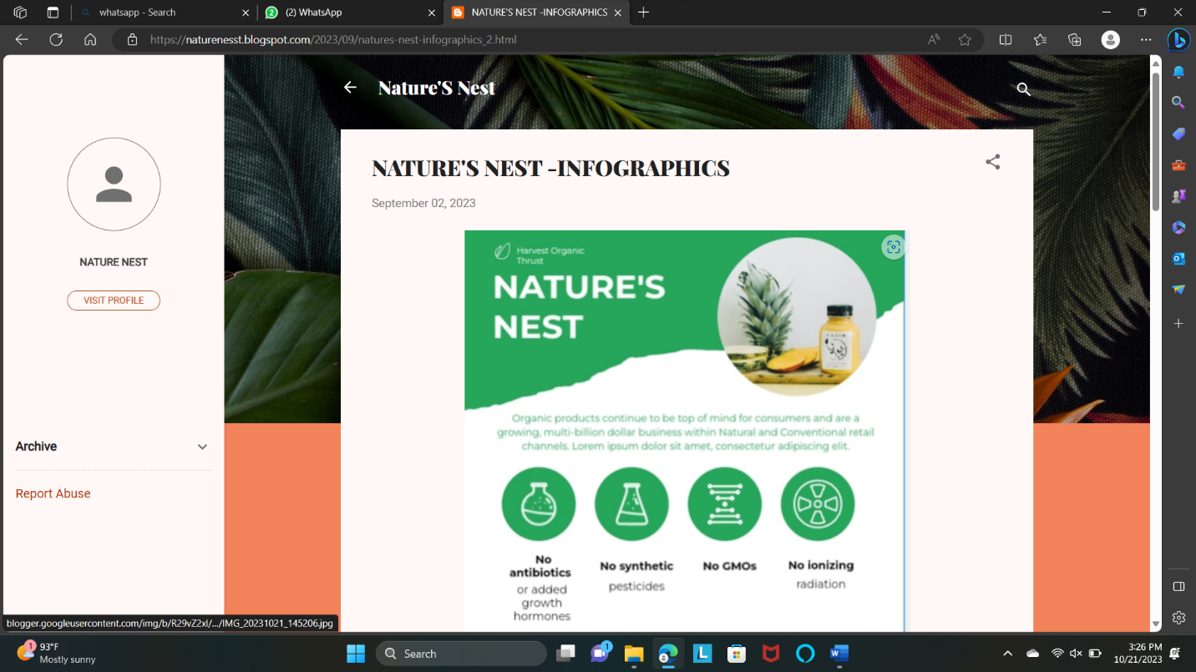

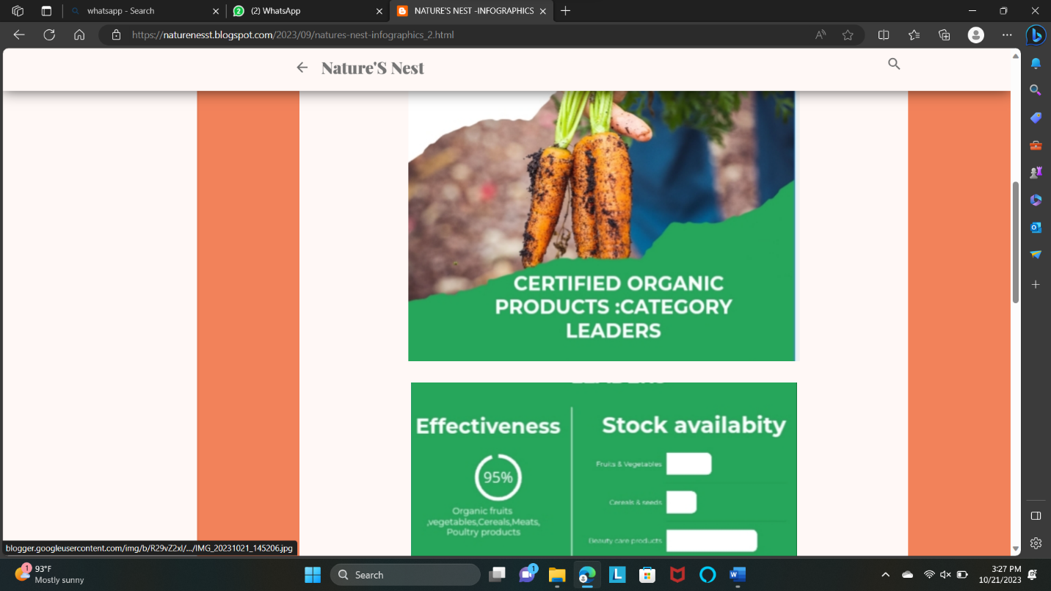

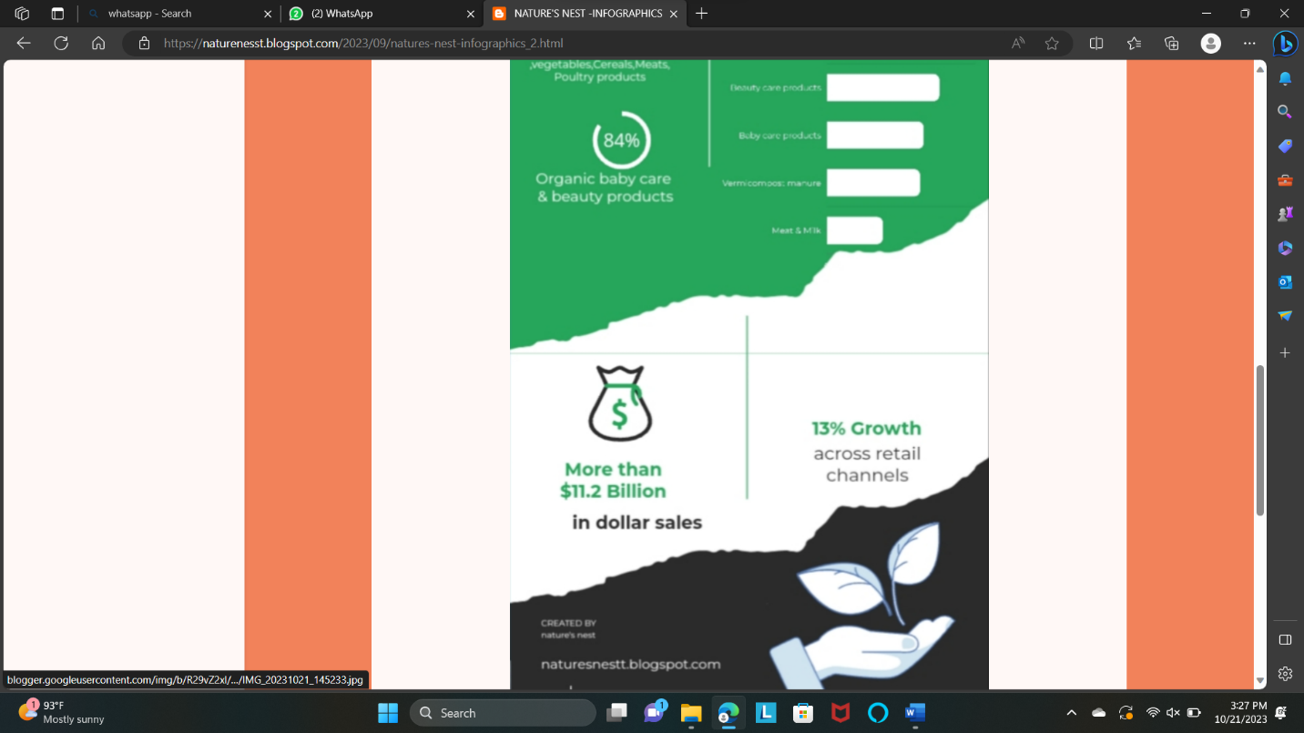

4.Create email newsletter design using MailChimp or canva tool.

Link: Email newsletter design using canva

<https://www.blogger.com/u/2/blog/post/edit/7958495218103469647/3487667664072275602?hl=en>

Screenshots:

